Use Case Diagram

# Light Up

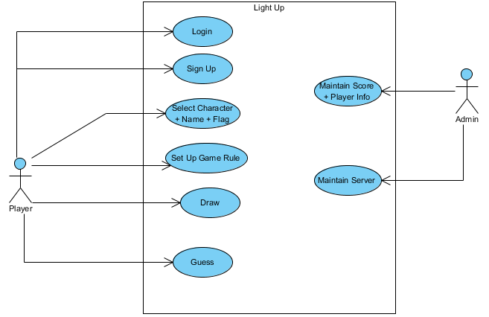

Class Diagram

# Light Up

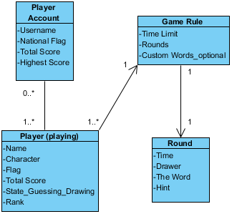

Sequence Diagram

# Draw & Guess

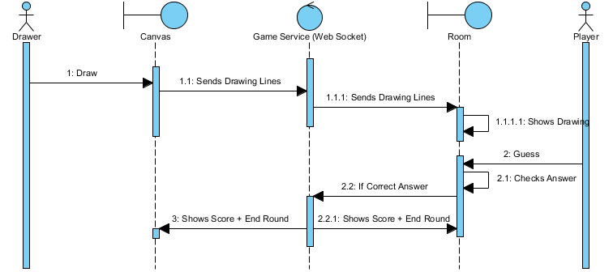

Sequence Diagram

# Login

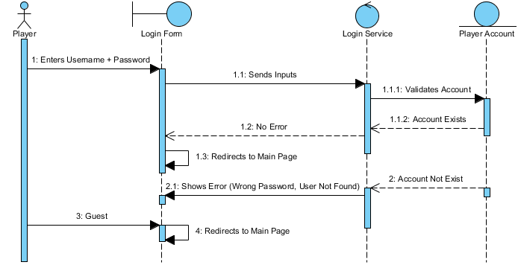

Sequence Diagram

# Select Character + Name + Flag

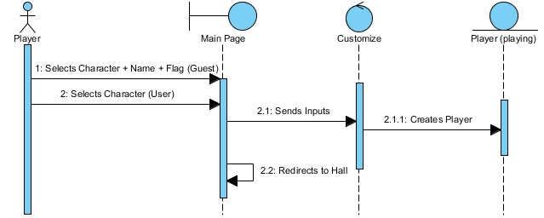

Sequence Diagram

# Set Up Game Rule

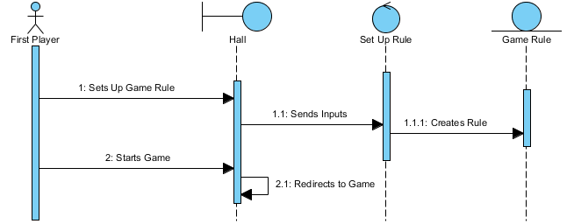

Sequence Diagram

# Sign Up

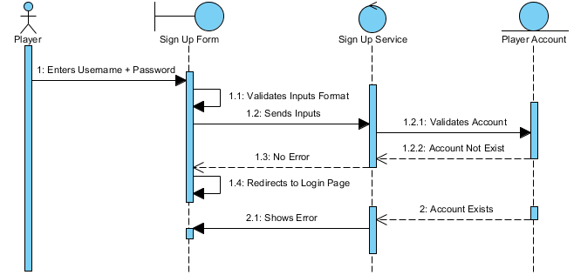

Object Diagram

# System Architecture

